The Effect of Stomach Contents on the
Relative Weight (W_{r}) of Smallmouth Bass and Walleye

Steven H. Ranney*
Gateway Environmental, LLC
76599 Gallatin Road
Gallatin Gateway, Montana 59730, USA

John M. Syslo
Montana Cooperative Fishery Research Unit and
Department of Ecology
Montana State University
Post Office Box 173460
Bozeman, Montana 59717, USA

Al Zale
U.S. Geological Survey, Montana Cooperative Fishery Research Unit,
and Department of Ecology, Montana State University
Post Office Box 173460
Bozeman, Montana 59717, USA

* Corresponding author: sranney@gw-env.com

Abstract
Relative weight (W_{r}) is commonly used to characterize fish condition. As a short-term indicator of fish condition, W_{r} could be biased high by the mass of recently ingested prey items. We estimated the maximum stomach volume of smallmouth bass Micropterus dolomieu and walleye Sander vitreus from the Midwestern United States and calculated the W_{r} of fish with empty stomachs (W_{rE}), filled stomachs (W_{rMAX}), and with observed stomach contents (W_{r}). No statistically significant difference existed between W_{r} and W_{rE} of smallmouth bass or walleye in substock, stock-quality, quality-preferred, preferred-memorable, or memorable-trophy length categories. Significant differences existed between W_{rE} and W_{rMAX} in all five length categories of smallmouth bass but only in the quality-preferred length category of walleye. Significant differences existed between W_{r} and W_{rMAX} in only the substock, stock-quality, and quality-preferred length categories of smallmouth; no significant differences existed between W_{r} and W_{rMAX} of any length categories of walleye. The greatest difference between W_{rMAX} and W_{rE} of smallmouth bass was 4.4 in the substock length category. Because most management target ranges for W_{r} are 10 units wide, fisheries managers need not consider the stomach contents of smallmouth bass and walleye when setting target W_{r} ranges.

Introduction
Length and weight data are important for fisheries management (Neumann et al. 2012) and are often used in combination (i.e., relative weight, W_{r}) to evaluate fish condition and the success of management actions (Blackwell et al. 2000); moreover, W_{r} is a concept that is easily communicated by fisheries managers to anglers. Relative weight is simple to calculate provided a species has a standard weight (W_{s}) equation (Anderson and Neumann 1996; Pope and Kruse 2007). The optimal W_{r} target was established as 100 W_{r} units, indicating a fish in “above average” condition (Wege and Anderson 1978; Pope and Kruse 2007). However, recently ingested food may affect W_{r}, inflating the estimated conditions of individual fish and affecting management decisions. We therefore evaluated the effect of stomach contents on W_{r} values of smallmouth bass Micropterus dolomieu and walleye Sander vitreus from the Midwestern United States by comparing W_{r} values of fish without stomach contents, with stomach contents, and with estimated-maximum stomach volumes.

Methods
We solicited length (mm), weight (g), and stomach contents weight (g; weighed to a minimum accuracy of 0.01 g) data of individual smallmouth and walleye from fisheries scientists and managers across the Midwestern and Western United States. We collected total length, total weight, and stomach-contents weight data from 1,133 smallmouth bass individuals from four impoundments in eastern South Dakota. For walleye, we collected length, total weight, and stomach-contents weight data from 953 individuals from six populations including impoundments in eastern South Dakota (n = 3), Nebraska (n = 1), Kansas (n = 1), and the Missouri River upstream of Ft. Peck Reservoir in Montana (n = 1). We calculated W_{r} of each fish (Murphy et al. 1990; Kolander et al. 1993) with three different values of body weight: including stomach contents (W_{r}), excluding stomach contents (W_{rE}), and including the estimated maximum stomach capacity (W_{rMAX}).
We estimated W_{rMAX} using non-linear quantile regression (Koenker and Basset 1978) with the quantreg package in R 3.1.0 (Koenker 2013). Quantile regression is a method for estimating functional relationships between variables for all portions of a distribution (Cade and Noon 2003). For both species, we regressed the 95th quantile of weight of the observed stomach contents (g) as a function of the total weight (g) of the individual using the formula
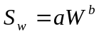,
where S_{w} = weight of the observed stomach contents of an individual (g), W = total weight of the fish (g) less the weight of the stomach contents, and a and b are derived from non-linear quantile regression (Koenker and Bassett 1978; Cade and Noon 2003). We then estimated maximum stomach contents weight of each individual fish. We added the maximum stomach contents weight to the weight of the fish—minus the observed stomach contents weight—to obtain W_{rMAX} values.

We used the Gabelhouse (1984) length categories [substock, stock-quality (S-Q), quality-preferred (Q-P), preferred-memorable (P-M), and memorable-trophy (M-T)] to analyze our data. We tested for significant differences between We calculated the percent difference among W_{r}, W_{rE}, and W_{rMAX} values using the equation
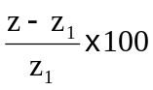,
where z = the experimental value (i.e., W_{rE}, W_{r}, or W_{rMAX}) and z₁ = the observed value (W_{r,} W_{r}, or W_{rMAX}), depending on the comparison made.
We tested for normality of our W_{rE}, W_{r}, and W_{rMAX} data with a Shapiro-Wilk test because W_{r} data are often non-normally distributed (Brendan et al. 2003; Pope and Kruse 2007). When data were distributed non-normally, we compared differences in the median values of W_{r}, W_{rE}, and W_{rMAX} by length category with Wilcoxon two-sample tests (Pope and Kruse 2007). Alpha for all statistical tests was set equal to 0.05. Statistical analyses were conducted using R version 3.1.0 (R Development Core Team 2014).

Results
Non-linear regression of maximum stomach volume on length provided adequate fits for both smallmouth bass (n = 22; p < 0.0005; R² = 0.69; Figure 1) and walleye (n = 29; p = 0.001; R² = 0.52; Figure 1).
Median W_{r} for smallmouth bass was 98.2 (1st Quantile (Q1) = 89.9; 3rd Quantile (Q3) = 106) W_{r} units across all length categories. Median W_{rE} for smallmouth was 97.2 (Q1 = 89.3; Q3 = 105.3) W_{r} units across all length categories. Median W_{rMAX} for smallmouth bass was 100.8 (Q1 = 92.8; Q3 = 109.0) W_{r} units across all length categories. For smallmouth bass, median W_{r}, W_{rE}, and W_{rMAX} were greater in the S-Q length category than in other length categories (Figure 2). Relative weight, W_{rE}, and W_{rMAX} decreased through the P-M length category, but increased in the M-T length category (Figure 2).
Median W_{r} for walleye was 94.6 (Q1 = 87.2; Q3 = 101.5) W_{r} units across all length categories. Median W_{rE} for walleye was 94.0 (Q1 = 86.7; Q3 = 100.6) W_{r} units across all length categories. Median W_{rMAX} for walleye was 95.5 (Q1 = 88.4; Q3 = 102.2) W_{r} units across all length categories. For walleye, condition was lowest in the S-Q length category (Figure 2). Relative weight, W_{rE}, and W_{rMAX} were higher in the substock length category, and increased in the Q-P, P-M, and M-T length categories.
Shapiro-Wilk tests on W_{r}, W_{rE}, and W_{rMAX} data indicated departures from normality for both smallmouth bass and walleye (p < 0.0001). Wilcoxon two-sample test comparisons of W_{r} and W_{rE} by length category indicated that there was no statistical difference in fish condition with and without stomach contents for smallmouth bass or walleye in either the substock, S-Q, Q-P, P-M, or M-T length categories (Table 1). Wilcoxon two-sample test comparisons of W_{rE} and W_{rMAX} indicated that there were statistically significant differences between W_{rE} and W_{rMAX} for smallmouth bass (p < 0.05) in all five of the length categories (Table 1). The percent differences here represent differences in weight of -3.3 g, -11.2 g, -20.5 g, -36.0 g, and -55.6 g for smallmouth that weighs 180 g, 280 g, 3250 g, 430 g, and 510 g, respectively. For walleye, W_{rE} was statistically different from W_{rMAX} in only the Q-P length category (Table 1). For a 420 mm walleye, the percent different indicated here is a difference of -14.4 g. When we compared W_{r} to W_{rMAX}, we found significant differences in the substock, S-Q, and Q-P length categories for smallmouth and no significant differences for walleye (Table 1). For smallmouth, the percent differences here represent differences of -2.4 g, -8.8 g, and -15.0 g for a smallmouth that weighs 180 g, 280 g, 3250 g, 430 g, and 510 g, respectively.

Discussion
The most common method of calculating W_{r} includes the stomach contents of fish. For our smallmouth bass data set, the differences among predictions of condition were less than 5 W_{r} units within a length category, though the differences between W_{r} and W_{rMAX} were statistically significant in all length categories. For walleye, the only statistically significant difference was between W_{rE} and W_{rMAX} in the Q-P length category. Though statistically significant differences are present in our data set, we do not believe that there are any biologically significant differences that would affect fisheries management.
Relative weight is a widely used tool to manage fish populations (Blackwell et al. 2000). Standard weight equations have been developed for over 60 species, many of which are targeted by anglers. Additionally, some W_{s} equations have also been developed for rare and nongame fishes (Bister et al. 2000; Richter, T. J. 2007; Rypel and Richter 2008; Ogle and Winfield 2009). Fisheries managers rely on condition factors in monitoring and managing fish populations and the results herein suggest that although stomach contents increase estimates of W_{r}, the increase is negligible. For example, though estimates of W_{rMAX} were significantly larger than estimates of W_{rE} in smallmouth bass, these differences were less than 5 W_{r} units, suggesting that even at maximum stomach capacity stomach contents of fishes would have little impact on management related decisions.
Stomach fullness is limited by rates of digestion or prey encounter (Breck 1993). Thus, stomach fullness for an individual fish at a given time will range from empty to full (Gosch et al. 2009). Predicting the likelihood at which an individual fish will be at maximum stomach capacity would be almost impossible because prey are patchily distributed (Gosch et al. 2009). The difference in the exponent, b, for smallmouth (b = 2.69) and walleye (b = 4.12) indicate that walleye have a higher rate of change in stomach capacity than smallmouth (Gosch et al. 2009). Thus, walleye experience a greater rate of change in stomach capacity with increasing length. This difference is likely a result of feeding strategies for these species. Walleye are considered specialist piscivores from hatch (Graeb et al. 2005) whereas smallmouth experience greater ontogenetic shifts in prey items: zooplankton to insects and small fish, culminating in crayfish and larger fish (Coble 1975). Another possible explanation are the potential morphological differences in digestive systems between smallmouth and walleye. Though we did not investigate stomach morphology, walleye and smallmouth may have a dissimilar number of pyloric caeca, which could affect digestion rates and stomach fullness.
Developers of W_{s} equations have not accounted for the influence of stomach-contents on total fish mass (i.e., Murphy et al. 1990; Gerow et al. 2005). Wege and Anderson (1978) discuss several factors that could influence W_{r} in largemouth bass Micropterus salmoides (e.g., population density, prey abundance, etc.) but do not discuss how stomach contents could affect W_{r}. Though the stomach contents of fishes is a measurement error and population density and prey abundance are physiological mechanisms, measurement error should be taken into account when collecting data that will be used in management-related decisions. However, our analyses suggest that there are little management-related differences among W_{rE}, W_{r}, and W_{rMAX}.
Nonlinear regression of observed stomach contents on length provided adequate fits for both smallmouth and walleye. The values for R² are both greater than 0.50, suggesting that 50% of the observed variation in the amount of observed stomach contents can be explained by fish length (Gotelli and Ellison 2004). This is reasonable, as larger fish would generally have higher numbers and sizes of stomach contents. However, the regression estimate for walleye was likely affected by several outliers in the M-T length category. Two fish in this length category had less than 20 ml of stomach contents which biased the regression downward. As a result, all of the observed stomach contents in the substock length category were higher than the estimated values, leading to estimates of W_{rMAX} being lower than estimates of W_{r} in the substock length category. We used a high density conversion factor (i.e., 1.05 g/ml) to estimate the “maximum of the maximum,” giving us a broader range of W_{r}, W_{rE}, and W_{rMAX} to compare. However, the small deviation between W_{rMAX} and W_{r} in substock walleye may not be a pragmatic concern for fisheries managers.
The data we analyzed were non-normal, thus we used non-parametric tests to compare W_{r} values among groups. Brenden et al. (2003) suggest that their R-test is the most appropriate for testing W_{r} data, but the statistical merit of W_{r} data continues to be debated (Pope and Kruse 2007). The R-test is likely the most appropriate and conservative method to compare W_{r} values, but the difficulty of computing the R-statistic and its associated significance value outweighs the only moderate improvement in testing power (Pope and Kruse 2007). Our study investigated the potential management concerns related to the effects of fish stomach contents on W_{r} values and was not an attempt to make any definitive conclusions regarding patterns in smallmouth or walleye condition. Thus, using non-parametric statistical analyses was an acceptable alternative to the R-test. However, results derived from the R-test may provide additional insight into the affects that fish stomach contents has on W_{r}.
To our knowledge, there has been no investigation into the lowest resolution of W_{r} at which fisheries managers can manage a population. Fish with W_{r} “close to” 100 are considered to be “in balance” with their food supply while fish with W_{r} less than 85 are underweight and fish with W_{r} greater than 105 are “more plump than necessary” (Flickinger et al. 1999). Most fisheries managers consider fish with a W_{r} value between 95 and 105 to be in good condition because W_{r} is a model of the 75th percentile of fish population weight as a function of length (Wege and Anderson 1978). When W_{r} target ranges are given for a species, the range encompasses 10 W_{r} units, suggesting that the lowest W_{r} resolution at which a fish population can be managed is 10 (see Blackwell et al. 2000). The maximum difference we found between W_{rMAX} and W_{rE} was 4.4 in the substock length category of smallmouth bass. As a result, we do not believe that fisheries managers should consider the stomach contents of the fishes in their populations when setting W_{r} target ranges.

Acknowledgments
We thank the contributors of the data used in this paper: T. Bacula, N. Olson, M. Quist, and T. Selch. C. Guy provided direction early in the development of this manuscript.

References
Anderson, R. O., and R. M. Neumann. 1996. Length, weight, and associated structural indices. Pages 447-482 in B. R. Murphy and D. W. Willis, editors. Fisheries techniques, 2nd edition. American Fisheries Society, Bethesda, Maryland.

Bister, T. J., D. W. Willis, M. L. Brown, S. M. Jordan, R. M. Neumann, M. C. Quist, and C. S. Guy. 2000. Proposed standard weight (W_{s}) equations and standard length categories for 18 warmwater nongame and riverine fish species. North American Journal of Fisheries Management 20:570-574.
Blackwell, B. G., M. L. Brown, and D. W. Willis. 2000. Relative weight (W_{r}) status and current use in fisheries assessment and management. Reviews in Fisheries Science 8:1-44.
Breck, J. E. 1993. Foraging theory and piscivorous fish: are forage fish just big zooplankton? Transactions of the American Fisheries Society 122:902:911.
Brendan, T. O., B. R. Murphy, and J. B. Birch. 2003. Statistical properties of the relative weight (W_{r}) index and an alternative procedure for testing W_{r} differences between groups. North American Journal of Fisheries Management 23:1136-1151.
Cade, B. S., and B. R. Noon. 2003. A gentle introduction to quantile regression for ecologists. Frontiers in Ecology and the Environment 1:412-420.
Coble, D. W. 1967. Relationship of temperature to total annual growth in adult smallmouth bass. Journal of the Fisheries Research Board Canada 24:87-99.
Flickinger, S. A., F. J. Bulow, and D. W. Willis. 1999. Small impoundments. Pages561 – 587 in C. C. Kohler and W. A. Hubert, editors. Inland fisheries management in North America, 2nd edition. American Fisheries Society, Bethesda, Maryland.
Gabelhouse, D. W., Jr. 1984. A length-categorization system to assess fish stocks. North American Journal of Fisheries Management 4:273-285.
Gerow, K. G., R. C. Anderson-Sprecher, and W. A. Hubert. 2005. A new method to compute standard-weight equations that reduces length-related bias. North American Journal of Fisheries Management 25:1288-1300.
Gosch, N. J. C., K. L. Pope, P. H. Michaletz. 2009. Stomach capacities of six freshwater fishes. Journal of Freshwater Ecology 24:645-649.
Gotelli, N. J., and A. M. Ellison. 2004. A primer of ecological statistics. Sinauer Associates, Inc., Sunderland, Massachusetts.
Graeb, B. D. S., T. Galarowicz, D. H. Wahl, J. M. Dettmers, and M. J. Simpson. 2005. Foraging behavior, morphology, and life history variation determine the ontogeny of piscivory in two closely related predators. Canadian Journal of Fisheries and Aquatic Sciences 62:2010-2020.
Knight, R. L., and F. J. Margraf. 1982. Estimating stomach fullness in fishes. North American Journal of Fisheries Management 2:413-414.
Koenker, R, and G. Basset. 1978. Regression quantiles. Econometrica 46:33-50.
Koenker, R. 2013. quantreg: Quantile Regression. R package version 5.05. http://CRAN.R-project.org/package=quantreg
Kohler, C. C., and A. M. Kelly. 1991. Assessing predator-prey balance in impoundments. Pages 257-260 in J. L. Cooper and R. H. Hamre, editors. Warmwater fisheries symposium I. U.S. Forest Service General Technical Report RM-207, Fort Collins, Colorado.
Lampert, W., and U. Sommer. 1997. Limnoecology: the ecology of lakes and streams. Oxford University Press, New York.
Murphy, B. R., M. L. Brown, and T. A. Springer. 1990. Evaluation of the relative weight (W_{r}) index, with new applications to walleye. North American Journal of Fisheries Management 10:85-97.
Kolander, T. D. D. W. Wilis, and B. R. Murphy. 1993. Proposed revision of the standard weight (W_{s}) equation for smallmouth bass. North American Journal of Fisheries Management 13:398-400.
Ogle, D. H., and I. J. Winfield. 2009. Ruffe length-weight relationships with a proposed standard weight equation. North American Journal of Fisheries Management 29:850-858.
Phelps, Q. E., K. A. Powell, S. R. Chipps, and D. W. Willis. 2007. A method for determining stomach fullness for planktivorous fishes. North American Journal of Fisheries Management 27:932-935.
Pope, K. L., and C. G. Kruse. 2007. Condition. Pages 423-471 in C. S. Guy and M. L. Brown, editors. Analysis and interpretation of freshwater fisheries data. American Fisheries Society, Bethesda, Maryland.
R Development Core Team (2008). R: A language and environment for statistical computing. R Foundation for Statistical Computing, Vienna, Austria. ISBN 3-900051-07-0, URL http://www.R-project.org.
Ranney, S. H., M. J. Fincel, M. R. Wuellner, J. A. VanDeHey, and M. L. Brown. 2010. Assessing length-related bias and the need for data standardization in the development of standard weight equations. North American Journal of Fisheries Management 30:655-664.
Richter, T. J. 2007. Development and evaluation of standard weight equations for bridgelip suckers and largescale suckers. North American Journal of Fisheries Management 27:936-939.
Rypel, A. L., and T. J. Richter. 2008. Empirical percentile standard weight equation for the blacktail redhorse. North American Journal of Fisheries Management 28:1843-1846.
Wege, G. J., and R. O. Anderson. 1978. Relative weight (W_{r}): a new index of condition for largemouth bass. Pages 79-91 in G. D. Novinger and J. G. Dillard, editors. New approaches to the management of small impoundments. American Fisheries Society, North Central Division, Special Publication 5, Bethesda, Maryland.

Table 1. Sample size, p-value from Wilcoxon two-sample comparison test (e.g., W_{rE} X W_{r}), and % difference in W_{r} calculated from whole individuals (W_{r}), individuals minus stomach contents (W_{rE}), and individuals at estimated maximum stomach capacity (W_{rMAX}) by five-cell length category. Asterisks (*) indicate comparisons that were significantly different.

Species | Statistic | Length category
Species | Statistic | Substock | S-Q | Q-P | P-M | M-T
Smallmouth bass | n | 274 | 410 | 205 | 151 | 93
Smallmouth bass | W_{rE} X W_{r} | 0.36 | 0.25 | 0.35 | 0.54 | 0.49
Smallmouth bass | % difference | -1.14 | -0.80 | -0.87 | -0.66 | -0.75
Smallmouth bass | W_{rE} X W_{rMAX} | < 0.005* | < 0.005* | < 0.05* | 0.01* | 0.049*
Smallmouth bass | % difference | -4.22 | -3.54 | -3.16 | -2.87 | -2.57
Smallmouth bass | W_{r} X W_{rMAX} | 0.012* | < 0.005* | 0.016* | 0.057 | 0.17
Smallmouth bass | % difference | -3.11 | -2.76 | -2.30 | -2.22 | -1.84
Walleye | n | 86 | 234 | 522 | 74 | 36
Walleye | W_{rE} X W_{r} | 0.31 | 0.38 | 0.46 | 0.66 | 0.58
Walleye | % difference | -1.25 | -0.80 | -0.53 | -0.78 | -1.25
Walleye | W_{rE} X W_{rMAX} | 0.46 | 0.09 | 0.009* | 0.28 | 0.24
Walleye | % difference | -0.86 | -1.54 | -1.86 | -2.31 | -2.74
Walleye | W_{r} X W_{rMAX} | 0.71 | 0.39 | 0.059 | 0.44 | 0.53
Walleye | % difference | 0.40 | -0.74 | -1.33 | -1.54 | -1.50

Figure Legends
Figure 1. Plots of observed stomach volume (ml) as a function of length (mm) for smallmouth bass Micropterus dolomieu (panel A) and walleye Sander vitreus (panel B). Each point represents the maximum total volume of prey observed in an individual stomach for each five-cell length category (Gabelhouse 1984) from each population. Note different scales on the x-axis.
Figure 2. Median relative weight with (W_{r}; open bars) and without stomach contents (W_{rE}; shaded bars) and at estimated maximum stomach capacity (W_{rMAX}; hatched bars) by length category (Gabelhouse 1984) for smallmouth bass Micropterus dolomieu (panel A) and walleye Sander vitreus (panel B). Error bars are first and third quartiles.

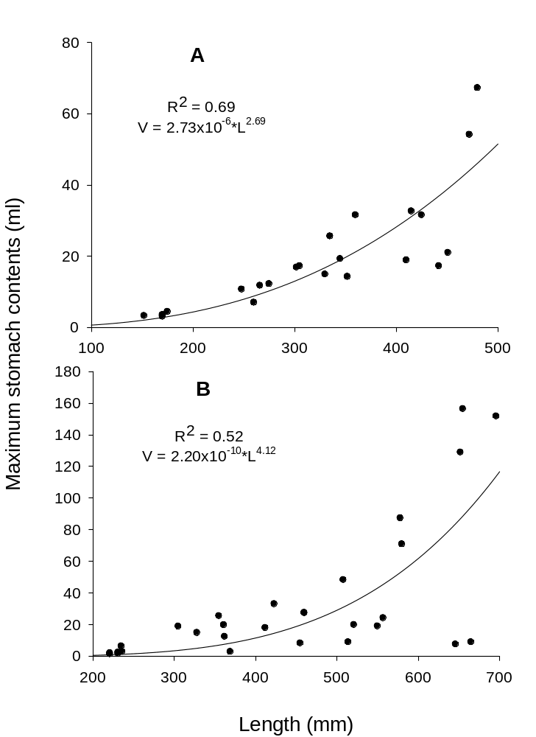
Figure 1.
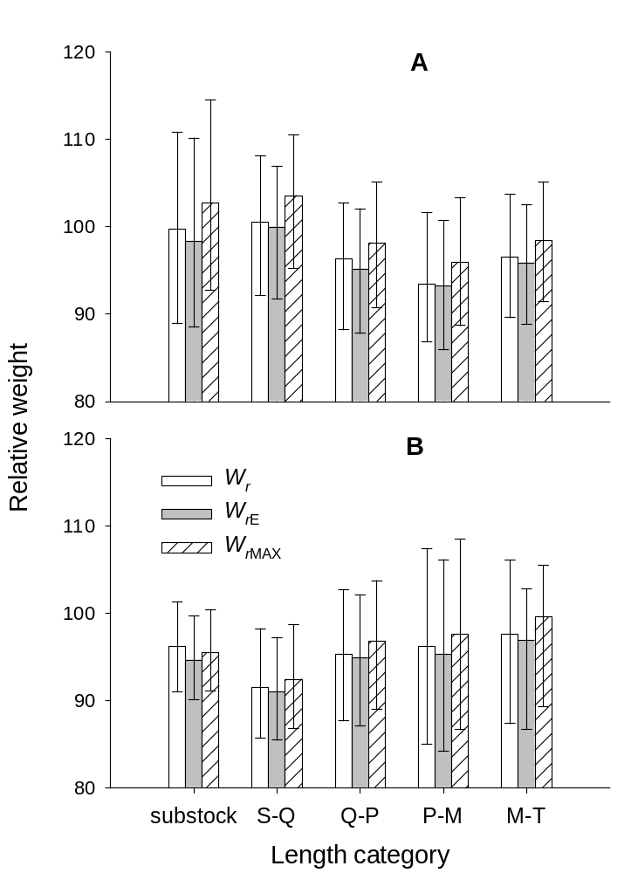
Figure 2.

